3PL: Guideline for Reconciliation of Shipping Costs with Partners (Couriers)

General Introduction
Currently, Boxme collaborates with different shipping partners based on market needs to offer various shipping solutions to sellers. Each shipping partner has its own pricing and service policies. Every month, partners submit a statement listing the orders along with the shipping costs based on the agreed schedule. These statements include successfully delivered orders, failed deliveries, and returned shipments. Shipping costs typically cover charges such as delivery fees, return fees, insurance, cash-on-delivery (COD) fees, additional fees, etc.
To ensure timely monitoring and payment of shipping costs, Boxme's reconciliation staff must check the reconciliation schedule, receive statements from shipping partners, and compare them with cost data from the Boxme system. Once the reconciliation process is complete and successfully verified, payments will be made to the shipping partners.
During the reconciliation process, staff need to upload the reconciliation file to the BMS system twice:
- First Upload: The staff only enter the Boxme tracking code or the partner's tracking code into the BMS system. This step retrieves the shipping cost data recorded in the BMS system, which serves as the basis for comparison with the partner's cost statement.
- Second Upload: After completing the reconciliation process and confirming the correct costs, the staff must delete the first uploaded file, then re-enter the correct cost details and upload the file again. This step ensures that the system records the reconciled orders and flags any duplicate orders in different reconciliation periods.

Detailed Guideline for Reconciling Shipping Costs with Partners

Step 1: Copy Reference Codes from the Partner’s Shipping Cost Statement
From the received cost statement, the reconciliation staff copies the Boxme code (BMxxxxxxxxxx) or the partner’s tracking code (each partner uses a different format). This code is then entered into the reconciliation template file (provided in Steps 2 and 3) before uploading it to the BMS system (Step 4).
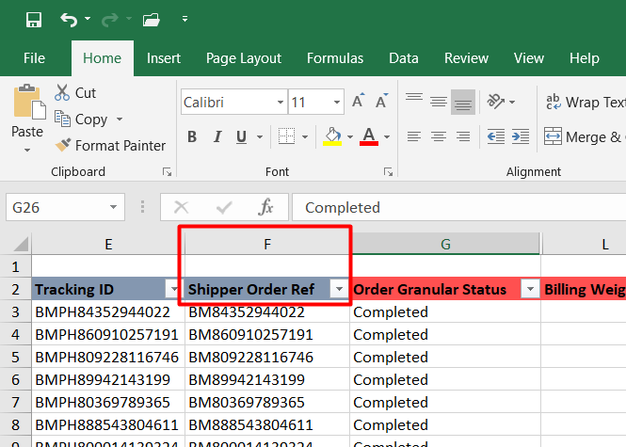

Step 2: Download the Shipping Cost Reconciliation Template
The reconciliation staff accesses the BMS system > Courier cost section to download the reconciliation template.
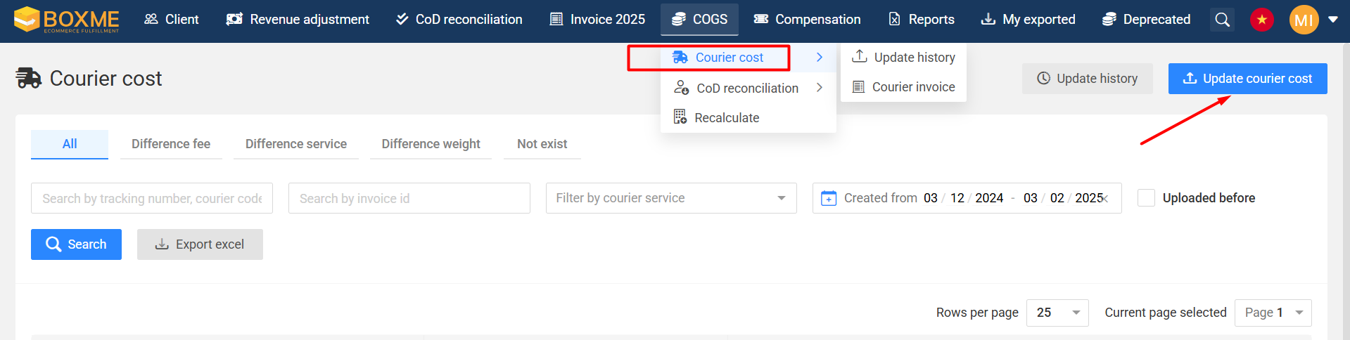
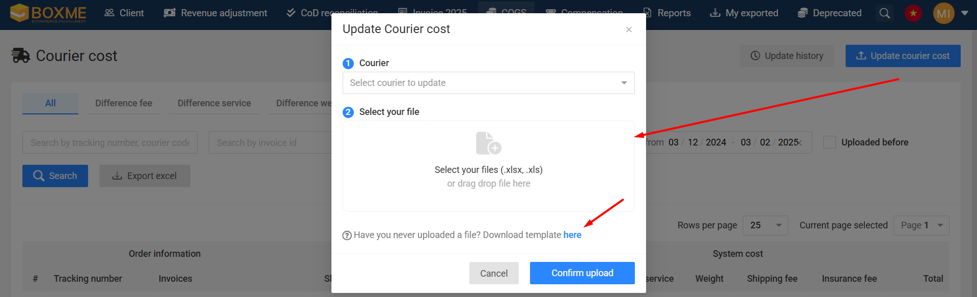

Step 3: Enter Information into the Shipping Cost Reconciliation Template
The staff pastes the copied Boxme code or partner’s tracking code (from Step 1) into the reconciliation template.
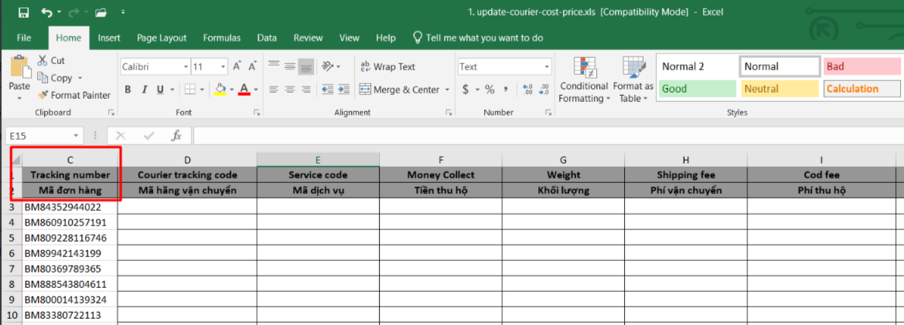

Step 4: Upload the Reconciliation File to the BMS System (1st time)
The staff selects the shipping partner to reconcile and uploads the completed reconciliation file containing the Boxme code or partner’s tracking code to the BMS system.
Note: This is the first upload to the BMS system as summarized in the General Introduction section.
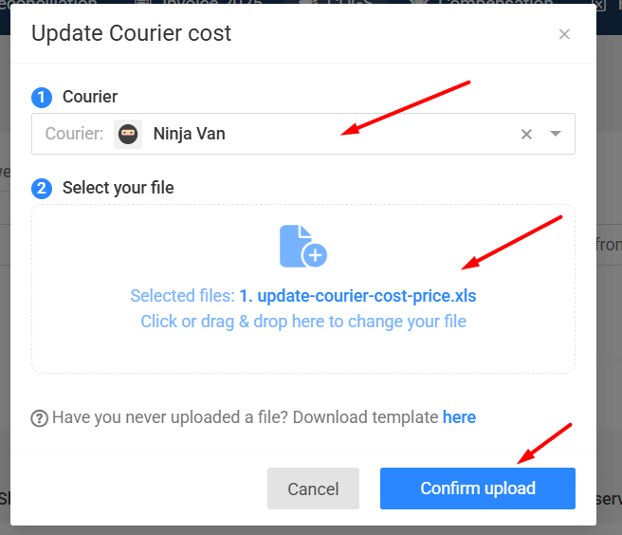

Step 5: Download Shipping Cost Data from the BMS System
After successfully uploading the reconciliation file, the system returns the recorded shipping cost data, which is used as the basis for comparison with the partner’s cost statement.
The reconciliation staff can retrieve this data using one of the following methods:
- Method 1: On the same screen where the reconciliation file was uploaded, click the Search button, then click Export Excel to download the data.
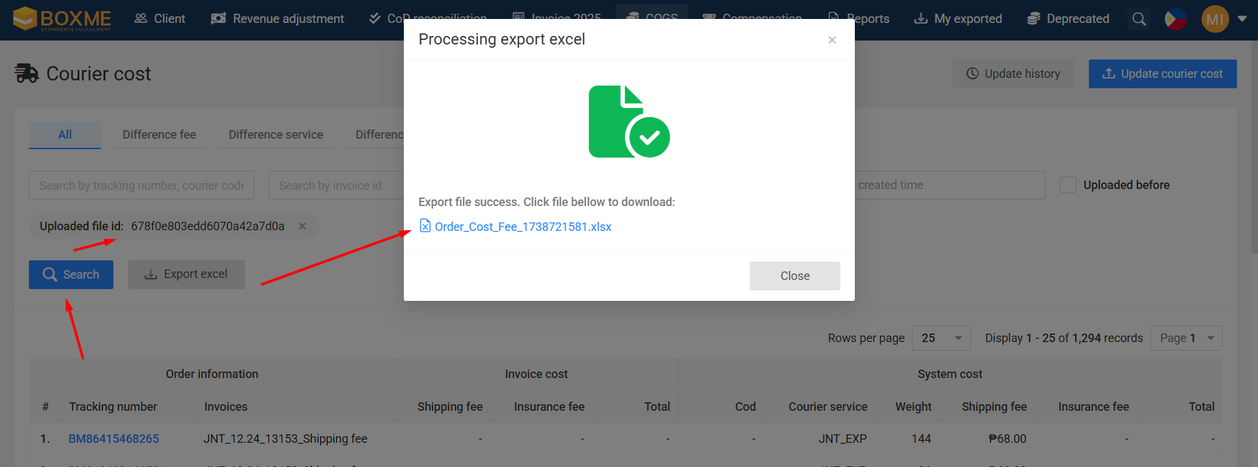
- Method 2: If the staff exits the screen, they can access it again by navigating to BMS > Courier cost > Update history. Here, they can find the uploaded files and click the arrow icon (under the Actions column) to reopen the previous upload screen, then click Export Excel to download the data.
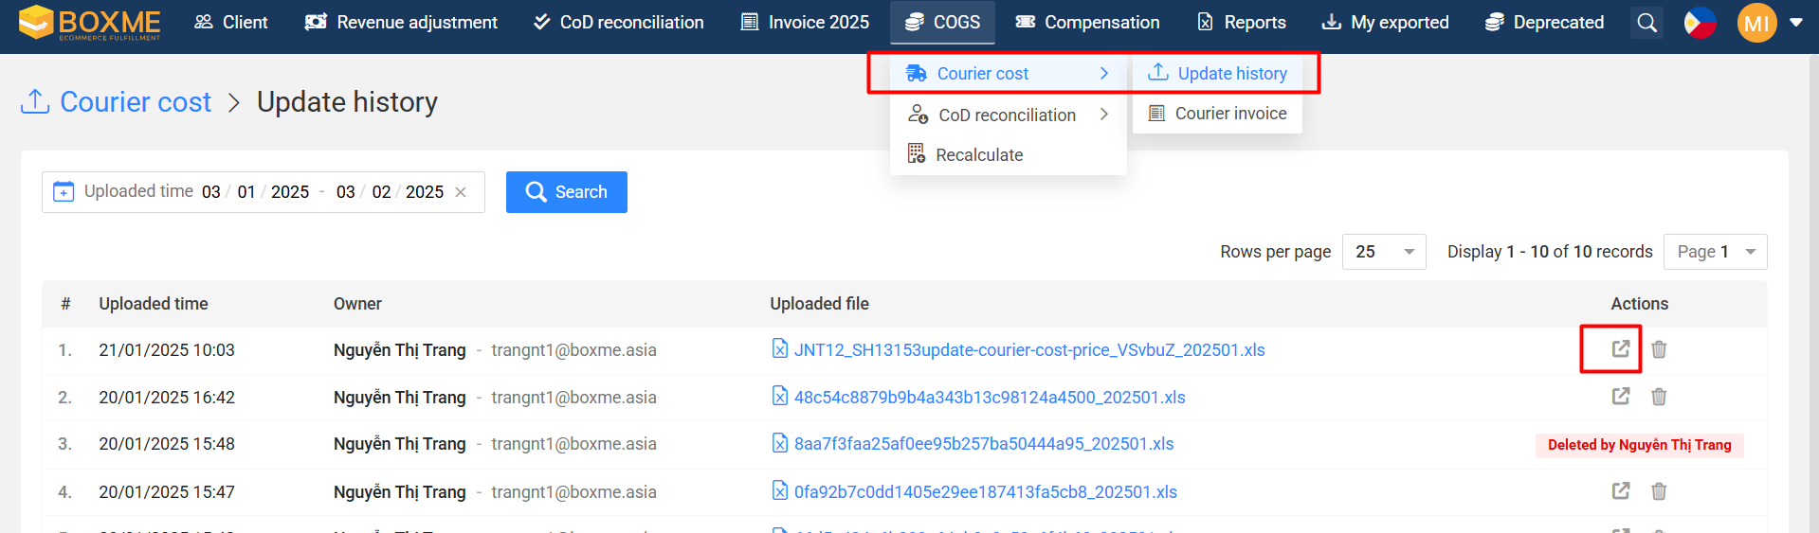
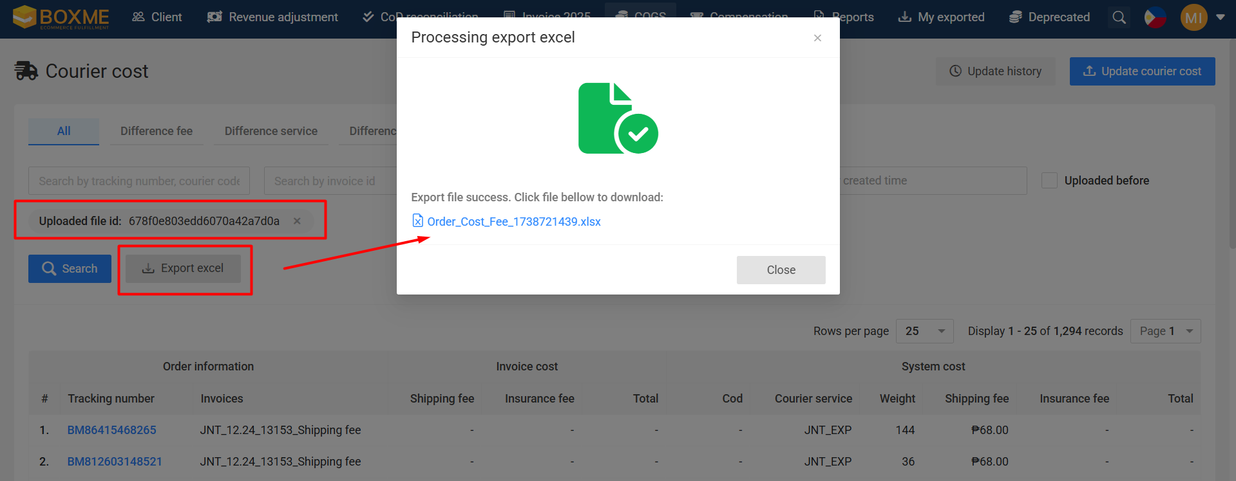

Step 6: Verify data from the Downloaded File
The reconciliation staff should pay attention to the cost columns labeled System, which contain the cost data recorded by the BMS system for comparison with the partner’s cost data.
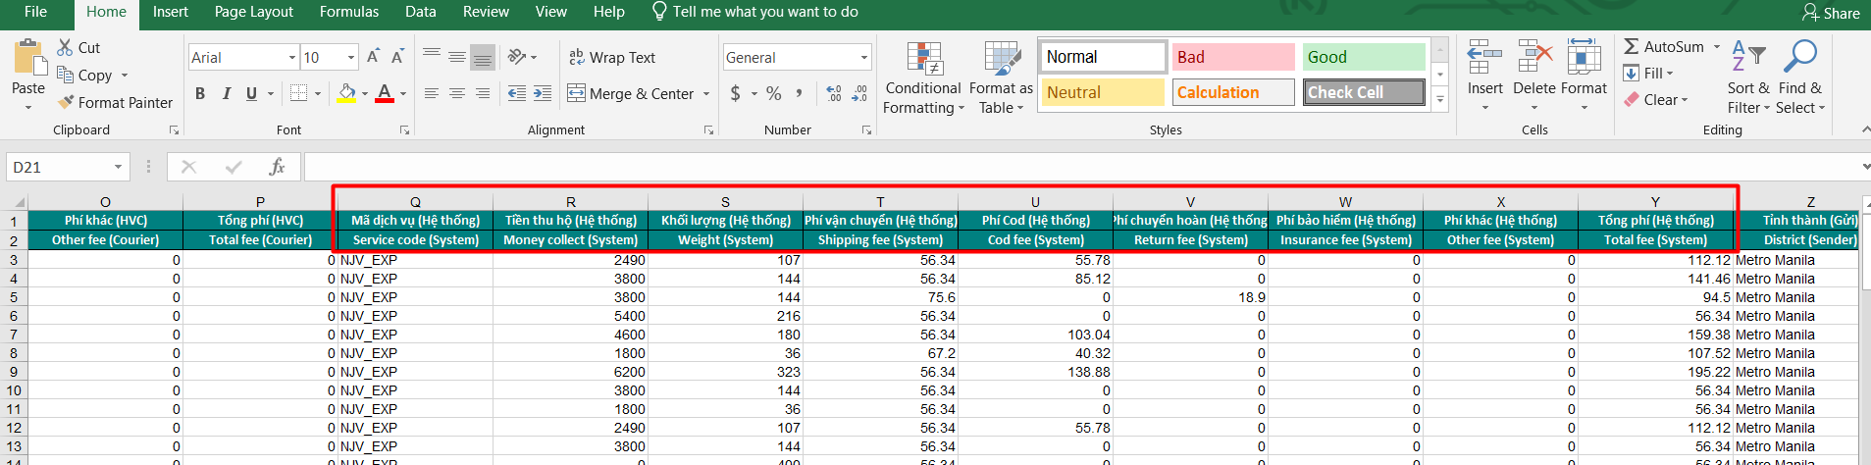
The staff then cross-checks the data with the partner’s cost statement and notes which orders will be paid. If there are cost discrepancies, the staff must investigate the cause.

Step 7: Possible Scenarios During Reconciliation
Case 1: Reconciliation data does not match, the discrepancies are usually caused by:
- The shipping partner updated its shipping cost rates, but Boxme has not yet received the new rates. In this case, the staff must work with the partner to confirm charges based on the old rates.
- Boxme has received and confirmed the new rates but has not yet updated them in the system. The staff should work with the pricing team to update the new rates and request the Boxme technical team to apply the changes to avoid discrepancies in future orders. The orders currently under reconciliation will be adjusted to the new confirmed rates.
- If the partner confirms that their cost data is correct and there have been no rate changes, the discrepancy usually falls into one of the following two cases:
- System miscalculates the cost: The reconciliation staff checks the parcel's weight in the system, then verifies the shipping cost against the partner's contract and contacts Boxme's technical team to identify any system miscalculations. If the system confirms an error, the staff will adjust the cost based on the partner’s pricing. Example: An order weighs 2kg, and the contracted shipping rate with the partner is 30,000 VND, but the system records the 2kg rate as 32,000 VND or 28,000 VND → the system has miscalculated the cost.
- Weight discrepancy: If the parcel's weight recorded in the system differs from the weight reported by the partner, the reconciliation staff will coordinate with the Sales and Operations departments to verify the actual product weight and volumetric weight (dimensional weight). In most cases, such discrepancies occur due to customers entering incorrect weight & dimensions in the Boxme system. If the discrepancy is caused by incorrect customer input, the staff will adjust the cost based on the partner’s pricing. Example: The system records the order weight as 3kg, but the weight measured by the partner is 4kg. Upon investigation, it is found that the discrepancy occurred because the customer entered incorrect product dimensions and product weight on the Boxme system.
Case 2: Reconciliation data matches, the reconciliation staff proceed to Step 8.

Step 8: Complete Reconciliation and Upload the Correct Cost Data to the BMS System (2nd time)
After reconciling all orders and confirming the correct costs, the staff must delete the previously uploaded reconciliation file (from Step 4).
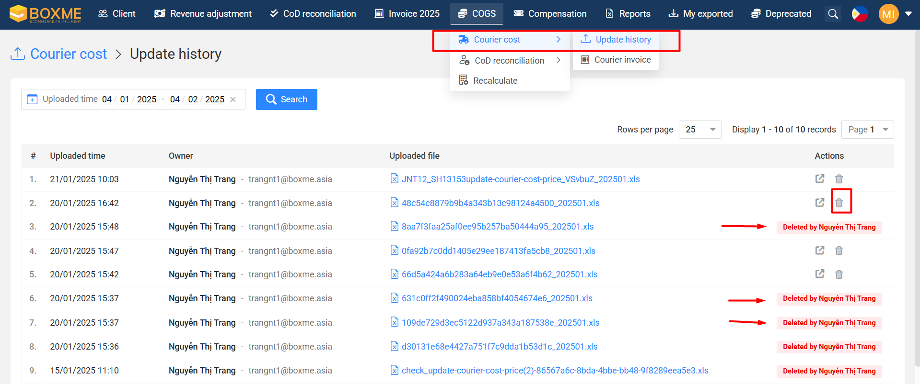
Then, they re-enter the correct cost details and upload the file again. This is the second upload as summarized in the General Introduction section. This step ensures that the system records reconciled orders and flags any duplicate orders in different reconciliation periods.
Note:
Currently, the system only supports uploading cost data by category (e.g., shipping fees, return fees, COD fees, insurance fees, etc.), recording orders separately for each cost type. Therefore, the reconciliation staff must upload each cost type separately and make notes for proper cross-checking and payment processing.
For 1st example, the image below shows the second upload for Shipping fees only. After finishing uploading Shipping fees, the staff can upload for other fees like Return fees, COD fees, Insurance fees, etc..
Explanation:
- Tracking code: Copy paste from the reconciliation file.
- Fee column(from H column to I column): please only fill in 1 fee, because the system only support 1 column can upload each time, example you fill in Shipping fee and upload first, then you will upload continue for COD fee, then continue for Insurance fee, etc...
- Invoice: It's up to the staff, or you can follow the format likeCourierCode-Feename-InvoiceMonth-Year. For example, NJV_ShippingCost_Febuary-2025.
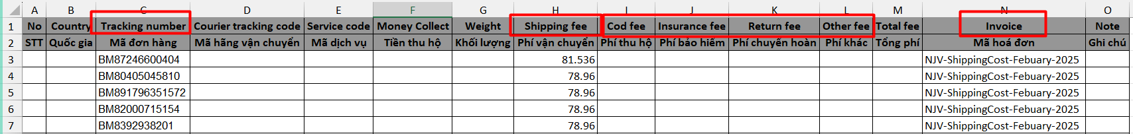
2nd example, we uploaded 2 time for GHN courier, 1st file for Shipping fee and 2nd file for Insurance fee.
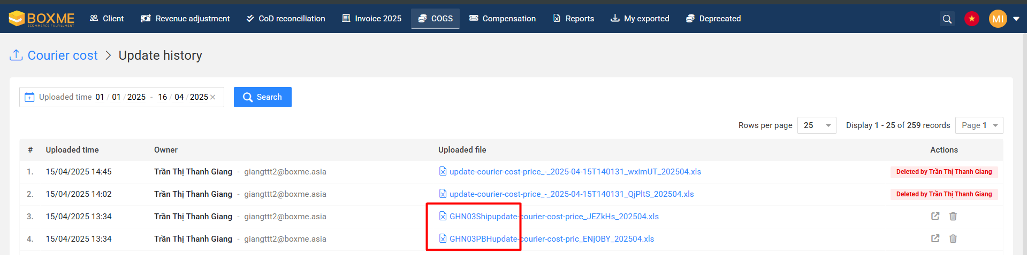
After uploaded, we can download excel file again to check if the data already record Courier fee by click Search > Export excel:
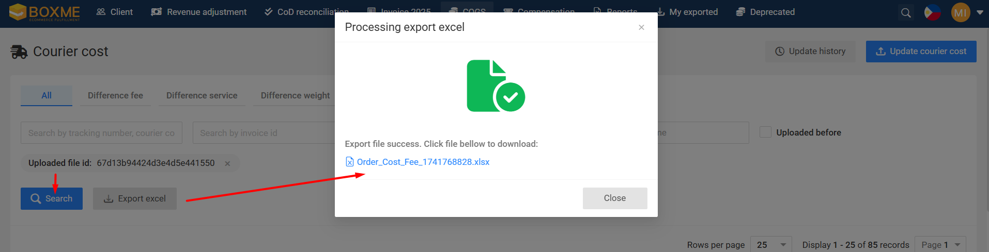
Then we can see Shipping fee (Courier) already record in the BMS system data while other fee still 0.
Besides that, we also can see Shipping fee (Courier) same cost with Shipping fee (System).
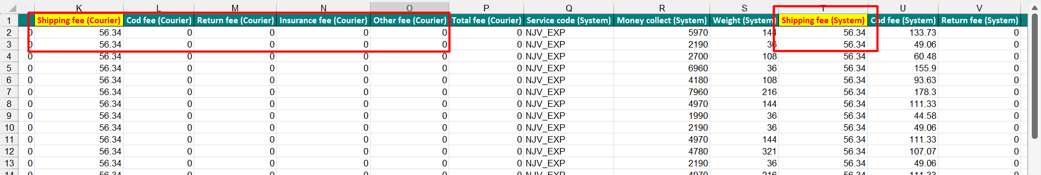

Conclusion
This guide covers all necessary steps for reconciling shipping costs with partners.

If you find this guide helpful, please give it a Like!

Wishing you a great day,
Henry

